Testing Mock Interview - 6+ YOE (Manual + Automation) - New York based candidate

Elvina

Selenium,Cucumber,TestNG,Junit,SQL,HPALM,Agile,Waterfall

Why do you want to leave your current job?

Because I want to work in automation aleast for 50 percentage, but in my current company oppurtunities aree less and I am getting less amount of automation work.

Why automation work reduced in your company?

What is the role as a senior hybrid test engineer you are doing in your company?

What is the team size?

Manual tester

Hybrid tester

Automation tester

Dev

What all are the scenarios you will automate when you have manual test cases?

Is 100 percentage automation is possible?

What all are the testcases you should not automate?

Howmany testcases you have in your application?

Howmuch time does it require to run the whole testcases of your application?

How frequently you are running your testcases?

What is the passing percentage of your whole testcases?

What could be the reason for the failure testcases in your automation regression run? Is it because of application issue or script issue?

What is the reason for the script failure when application doesn’t have any issues?

Will get issue sometimes because of the chain is breaking with other funcationality change

Basic architecture of your framework,components and testcases other stuffs related to your framework?

What is the advantage of using page object model?

Where you will write assertions whether in page class or in someother class?

Why you are including assertion class in page class? What is the good practice for assertion class?

What is the disadvantage of page object model?

Single responsibility principle? (one of the design pattern principles)

Can we achieve parallel execution using singleton pattern?

What is souce lab?

What does mean by singleton pattern?

What is the connection between souce lab and remote webdriver?

How you are running your testcases on soucelab?

Desired capabilities?

Selenium Grid?

What is the concept of Grid?

What is the best practice to design a feature file? When we have to use then,given,and,when,background, scenario outline?

What is the difference between hooks and background?

Where do we specify hooks? Inside class file or inside feature file?

What is the difference between data table and examples?

Whose responsibility is this is to write feature file?

Do share your feature file with developer and share holders and PO?

How comfortable you are in selenium?

Why do you get stale element exception?

Tell me the difference between implicit wait and explicit wait?

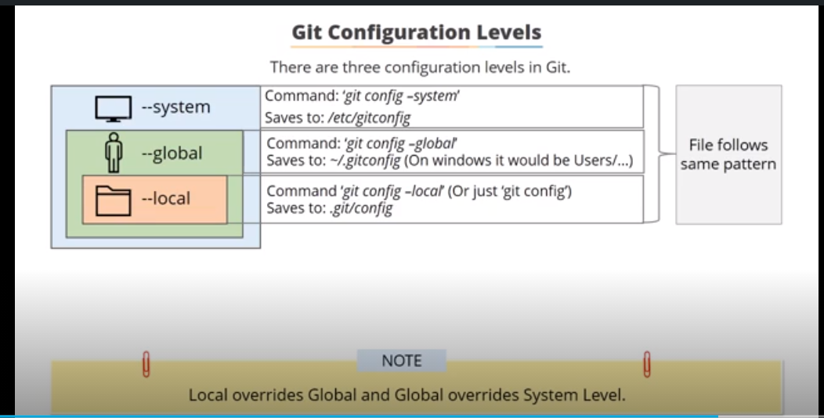

git commit -m "initial version"

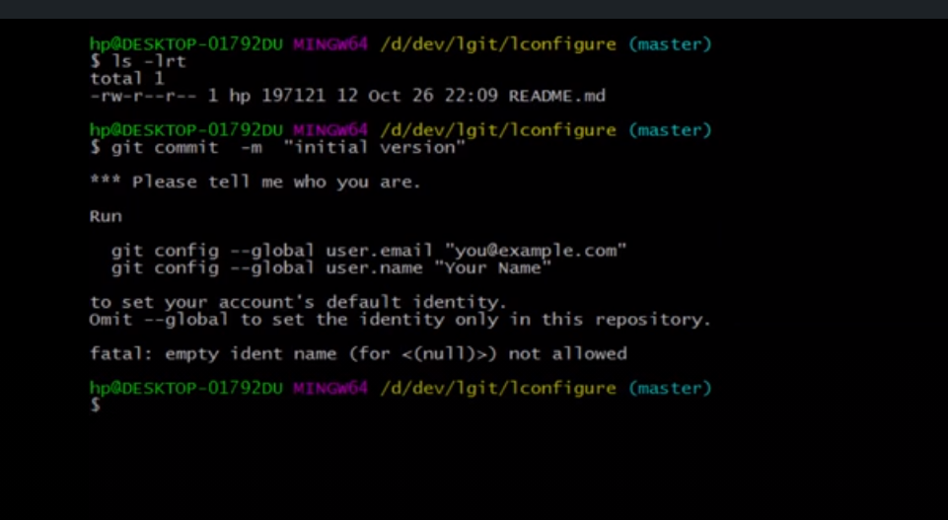

git config --global user.name "surendarg97"

git config --global user.email "surendarg97@gmail.com"

git config –list

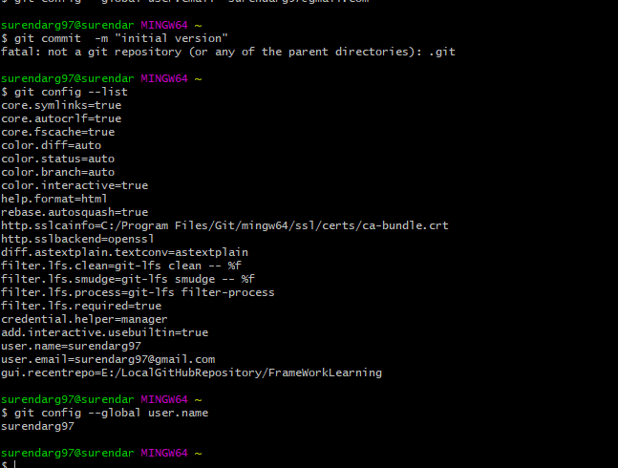

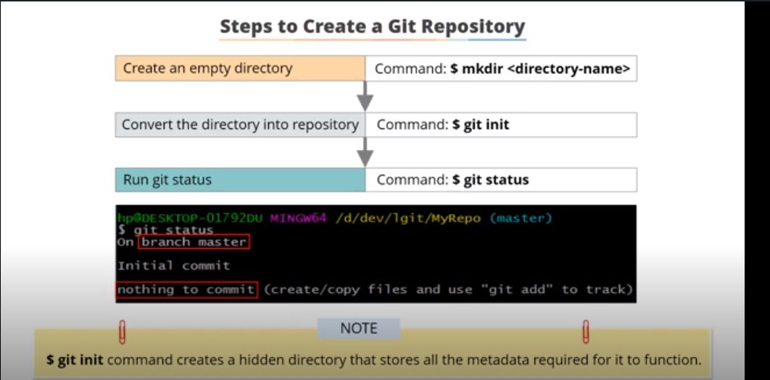

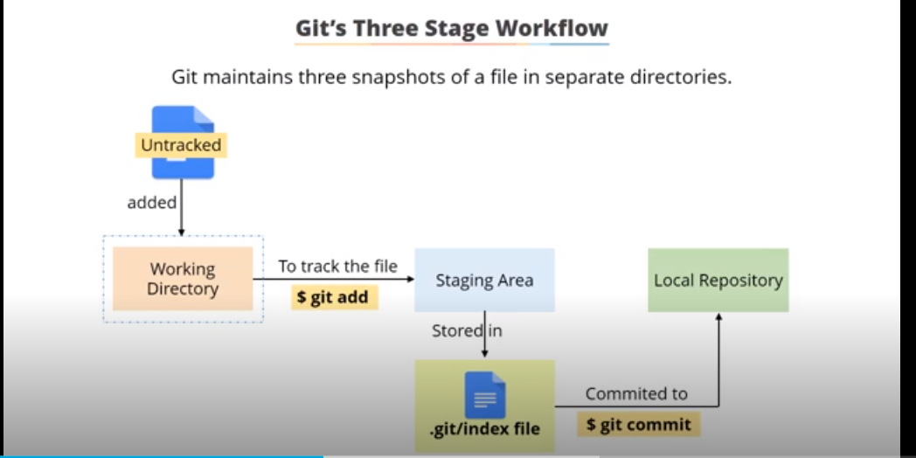

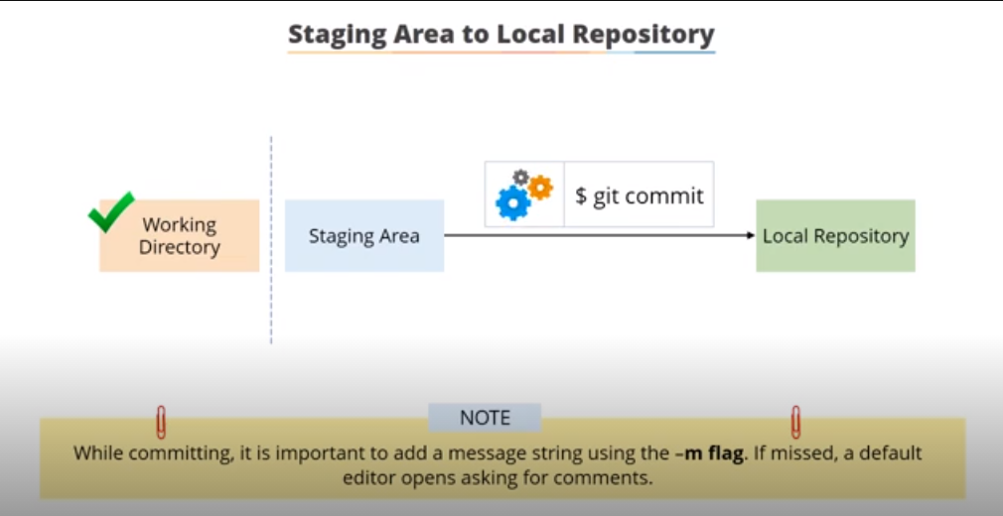

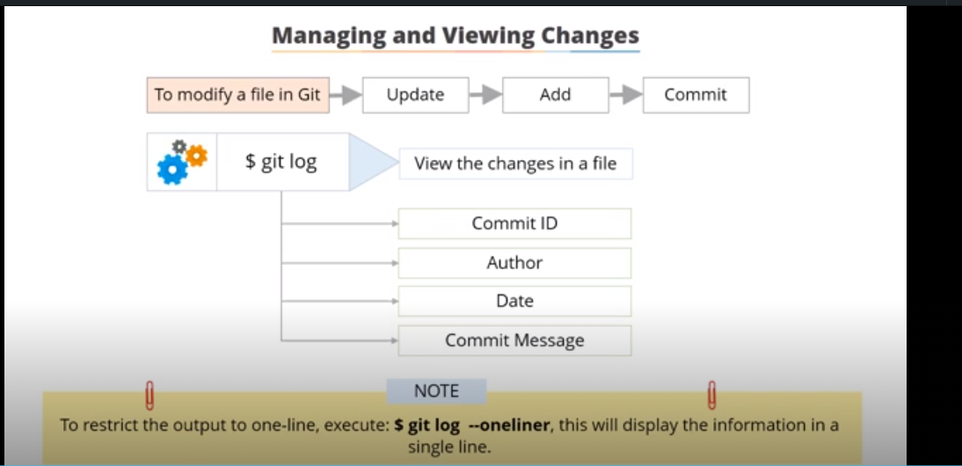

git log –oneline

